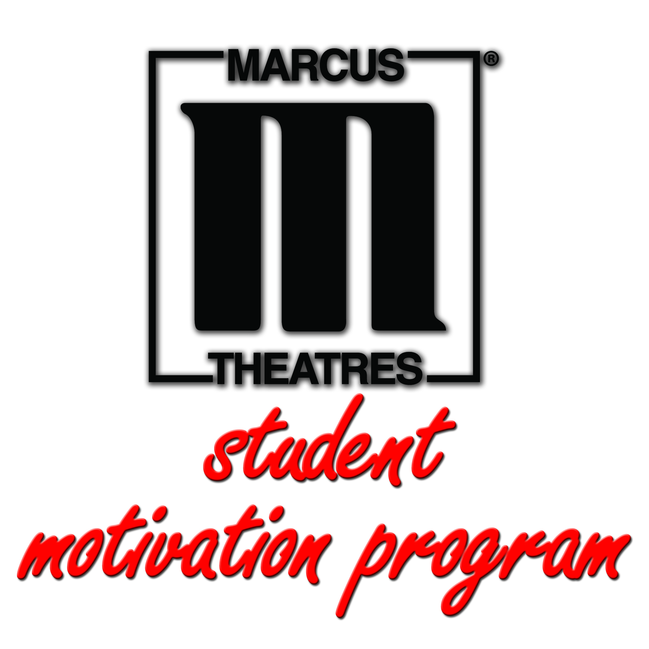

Eight Reasons to Reward Students With a Trip to the Movies

Once your school or district is approved to join the Marcus Theatres’® Student Motivation Program, you will receive a number of passes based on enrollment totals. How you gift these passes is completely up to you, but we encourage them to be used for rewarding academic achievement, good reading habits, perfect attendance and positive connections.

Please refer to the ideas below if you need inspiration for how to incorporate the passes into your programs. Regardless of how they are distributed, one thing is certain — students love getting rewarded with the gift of entertainment!

Academic Achievement

Student of the month: Add extra incentive for school-wide recognition.

“We use our passes for the student of the month program, which recognizes 12 students in grades six through eight each month.” — Program participant

Spelling bees: F-r-e-e m-o-v-i-e-s may be easy to spell, but they’re not easy to win!

“We use our passes to award finalists for spelling and geography bees.” — Program participant

Good Reading Habits

Consistency: Whether in or out of the classroom, keep the positive momentum going.

“Our students are motivated to read outside of class. Those who reach or surpass their goals will be rewarded.” — Program participant

Excellence: Reward students who go above and beyond in reading.

“We use the passes for Accelerated Reading awards that are given out on the last day of the school year at our awards ceremony — perfect timing for summer vacation!” — Program Participant

Perfect Attendance

Raffle: Create a fun and friendly attendance competition as a way to increase daily attendance.

“Each day a student comes to school on time, they will receive a raffle ticket. Drawings will occur every two weeks. The more they come to school, the more they increase their chance of winning.” — Program participant

On-time percentage: Use passes as a continuous reminder for punctuality.
“We use the passes as monthly rewards for students who achieve 96% or higher attendance.” — Program participant

Positive Connections

Core values: When a student makes a choice aligned with one of your core values, award them with a merit. Once a certain number of merits are achieved, present them with a Marcus Theatres pass.

“It’s our way of showing gratitude for choices made, positive leadership and community service both within our school and surrounding neighborhoods.” — Program participant

Acts of kindness: Nothing says “caught you being good” like a trip to the movies.

“When we ‘catch’ a student being good, we enter their name into a weekly drawing for a chance to win a movie pass.” — Program participant

